How to push packages to JFROG

1.First download it to your local machine,from alkamer jfrog.

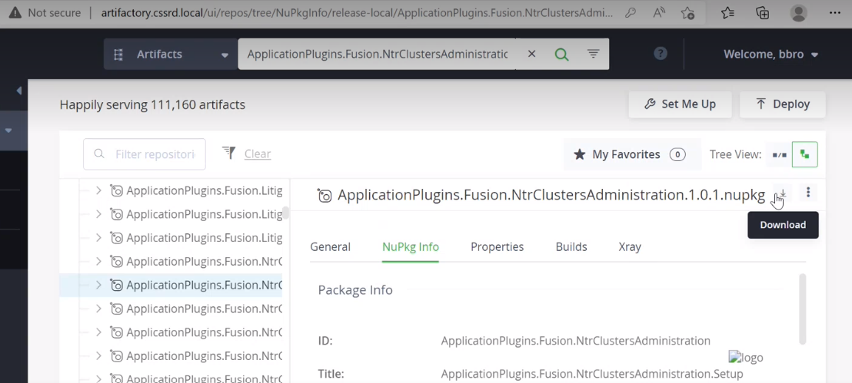

2.Then click on deploy to Israel jfrog ,you will get below option

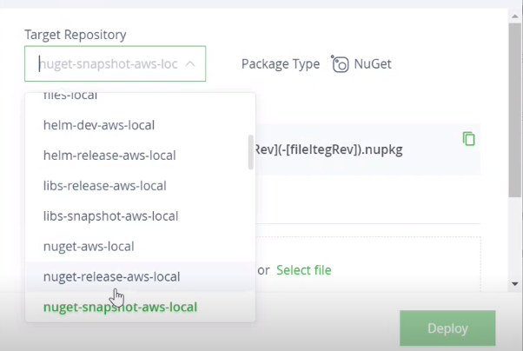

You have to upload in both region **nuget-release-aws-local** and **nugent-snapshot-aws-local**